SQL ASSIGNMENT-1[UNIT-1]
Name: KAVYA.T
Class: 1st M.SC COMPUTER SCIENCE
---------------------------------------------------------------------------

- Find the total and the average sales (display total_sales and avg_sales):
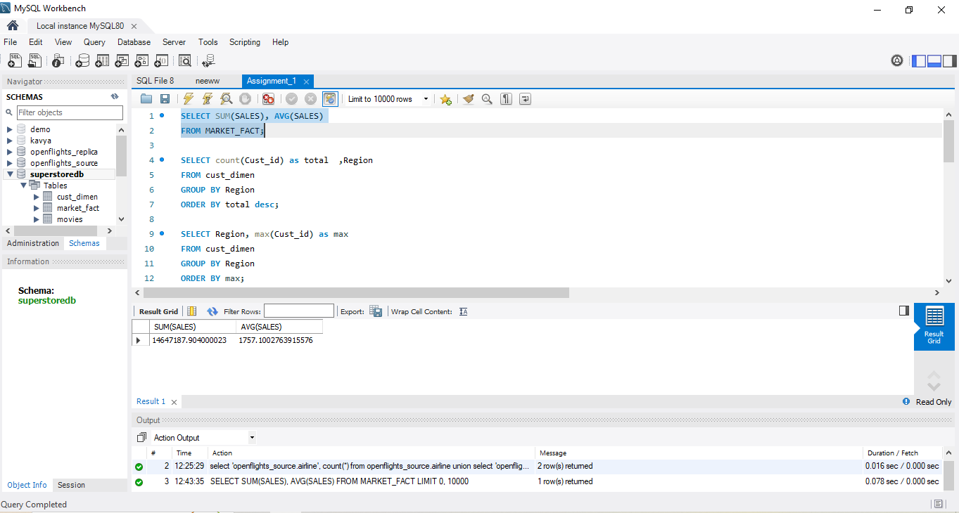

- Display the number of customers in each region in decreasing order of

no_of_customers. The result should contain columns Region, no_of_customers:
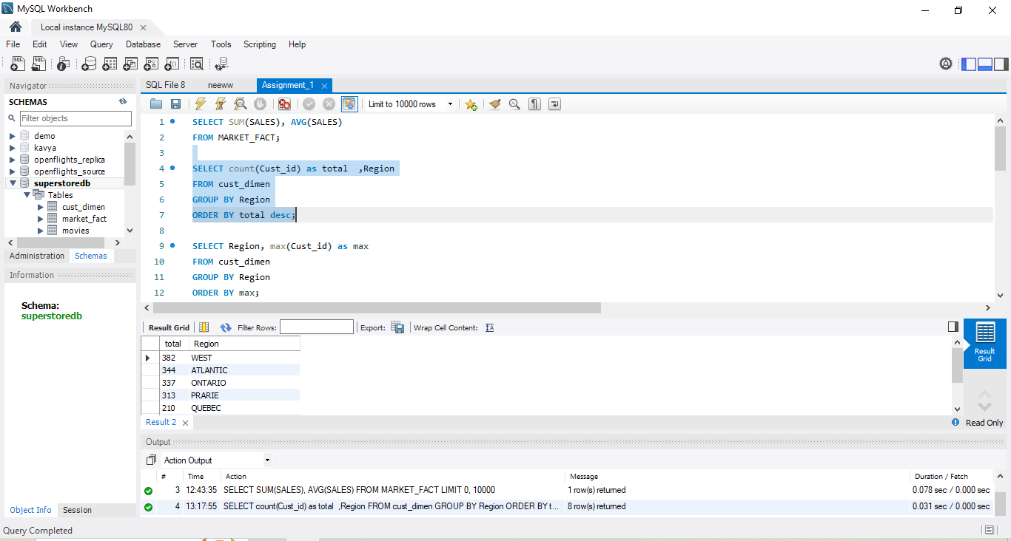
- Find the region having maximum customers (display the region name and max(no_of_customers)
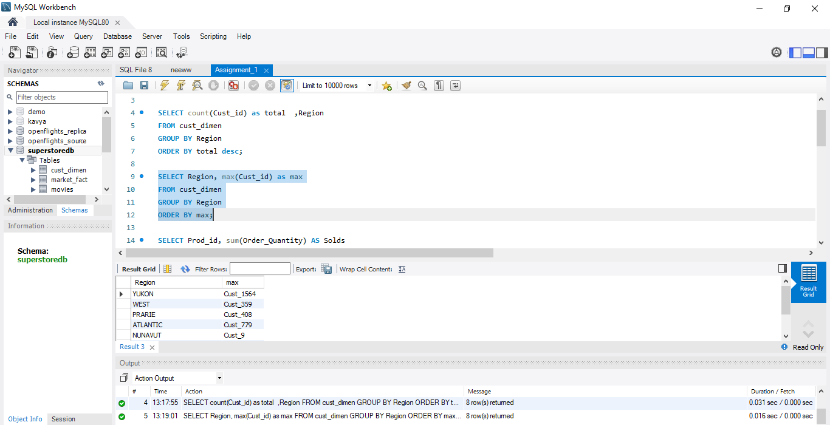

D. Find the number and id of products sold in decreasing order of products sold
(display product id, no_of_products sold).
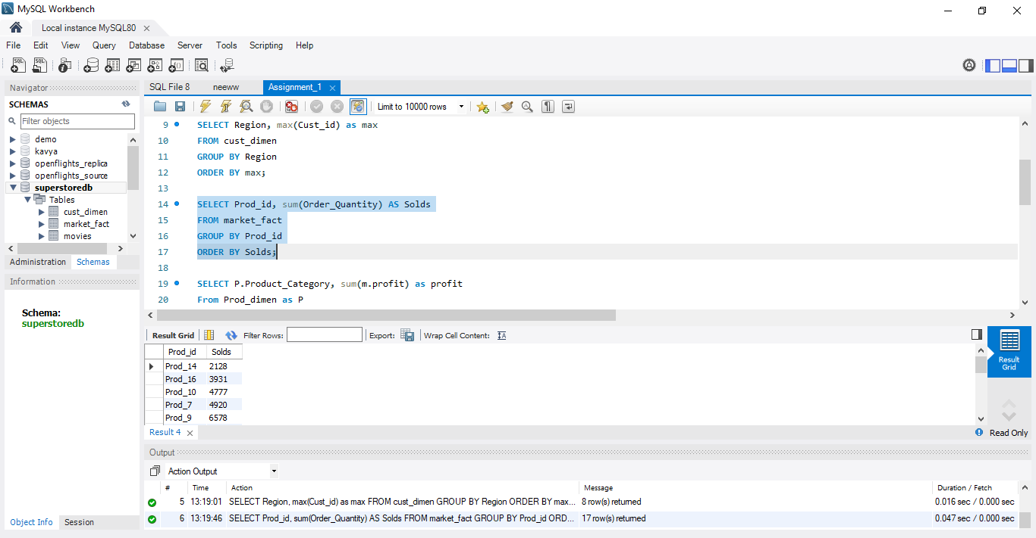

- Display the product categories in descending order of profits (display the product category wise profits i.e. product_category, profits)?
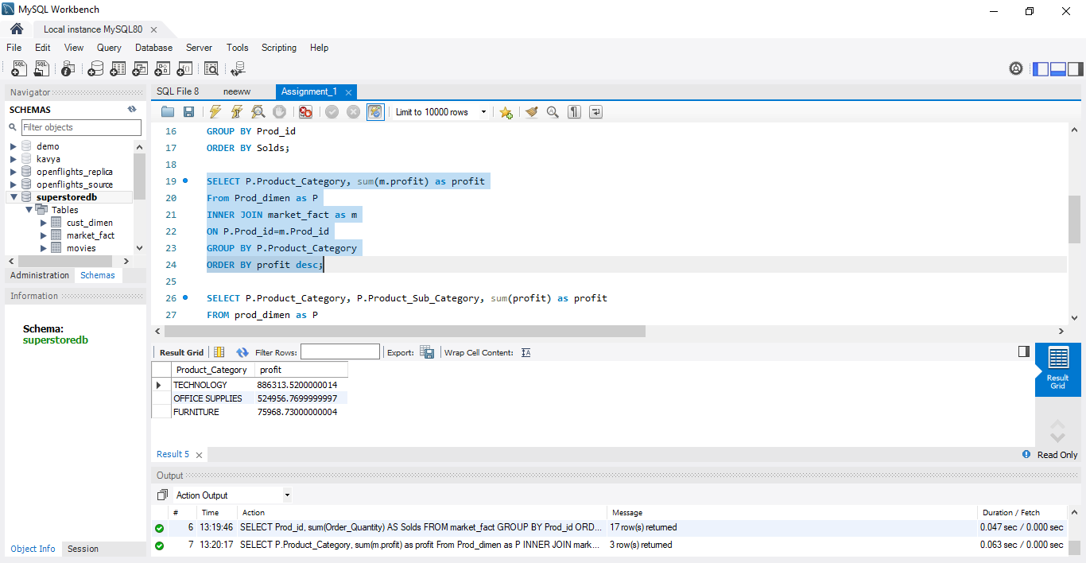

- Display the product category, product sub-category and the profit within each sub-category in three columns.
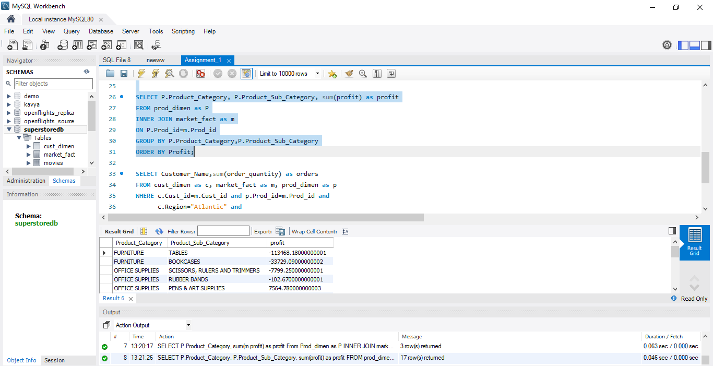

- Find all the customers from Atlantic region who have ever purchased ‘TABLES’ and the number of tables purchased (display the customer name, no_of_tables purchased)

